The procedure for the remote defense of the diploma thesis

1. Preparation of the diploma thesis for the defense using the APD

(Diploma Theses Archive) system

1.1. After entering the thesis in the Dean’s Office USOS system, the Student and the Supervisor both gain access to working in the APD system.

If your thesis is not available in the APD system, please contact the employee of the Dean’s Office responsible for the given field of study.

In order to log into the APD system, you need to:

- enter the website address (https://apd.uek.krakow.pl/) in the web browser, and then select the "log in" link (upper right corner of the screen),

- in the login form for the CUE’s Central Authentication System (CAS) that will appear, provide your ID and password.

Access to individual stages is possible after entering in the “MY THESES” (MOJE PRACE) tab in the main menu of the system:

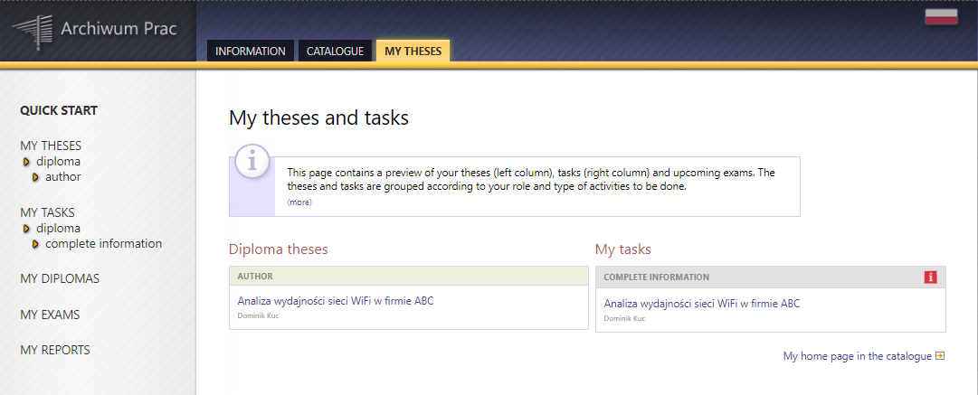

In the APD system, several steps (stages) must be followed, during which the thesis is uploaded into the system, checked by the anti-plagiarism system, and evaluated by the Reviewers. The progress is presented graphically on the timeline showing the Status of the thesis (“Status pracy”), which indicates what is to be done within the given step and who is responsible for its implementation:

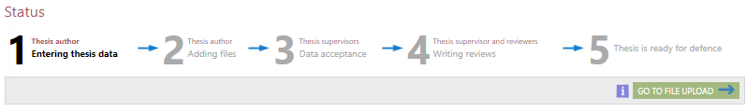

Please note: in the APD system, all users have access to the catalogue with the list of theses, and to the search engine. The content of the thesis and the reviews are available only to the author of the work – the Student, to his/her Thesis Supervisor (i.e. Dissertation Advisor), and to the Reviewer.
1.2. Having gained access to working in the APD system, the Student proceeds to step 1 “Entering thesis data” (“Wpisywanie danych pracy”), that is, he/she enters the title of the thesis, the abstract, and the keywords in Polish and in English (see the screen below). Then he/she clicks on the “Proceed to add files” (“Przejdź do dodawania plików”) button and continues to step 2 “Uploading thesis files” (“Przesyłanie plików z pracą”).

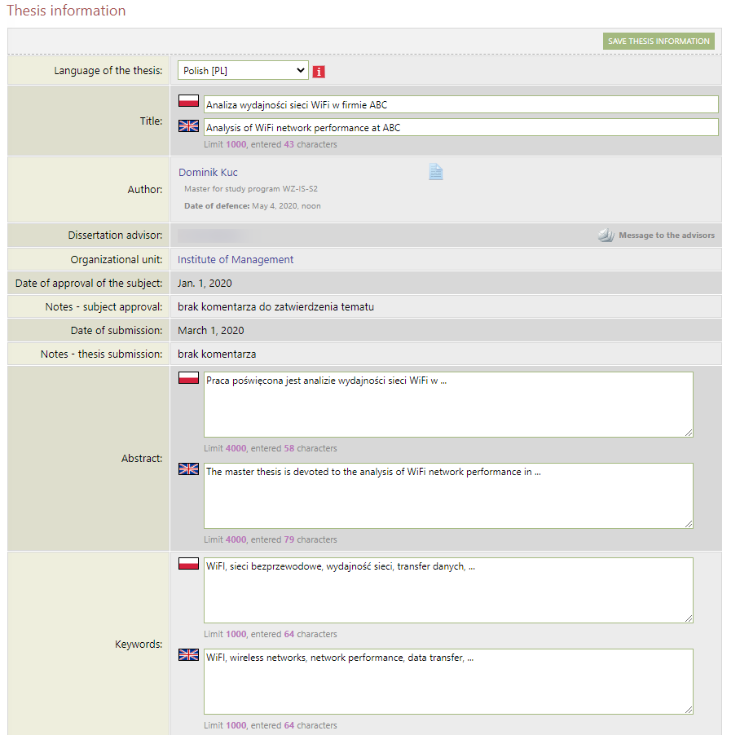
1.3. In the APD system, the Student proceeds to step 2. “Uploading thesis files” (“Przesyłanie plików z pracą”), in which he/she enters the file with the thesis in PDF format and any attachments to the thesis (see the screen below). He/she then clicks on the “Submit to Supervisor for approval” (“Przekaż do zatwierdzenia przez opiekuna”) button and proceeds to step 3 “Data approval” (“Akceptacja danych”).

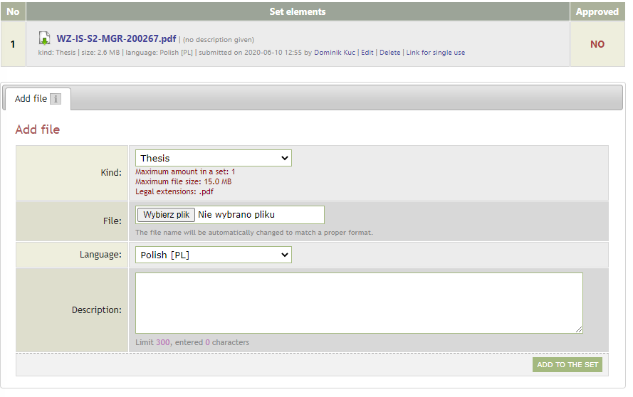
1.4. In the APD system, the Supervisor performs step 3 “Data approval” (“Akceptacja danych”), that is, he/she checks the thesis and any additional data sent by the Student (title, summary, keywords), and subsequently:
  - If the thesis requires improvement, the Supervisor clicks on the “Submit for improvement” (“Przekaż do poprawy”) button (next, it is possible to enter a comment about the reason for directing the thesis for improvement, whereas the thesis itself is sent back to step 2).
  - If the work does not require improvement, the Supervisor sends it to be examined by the JSA (Uniform Anti-Plagiarism System) by clicking on the “Request an examination” (“Zleć badanie”) button (see the screen below).

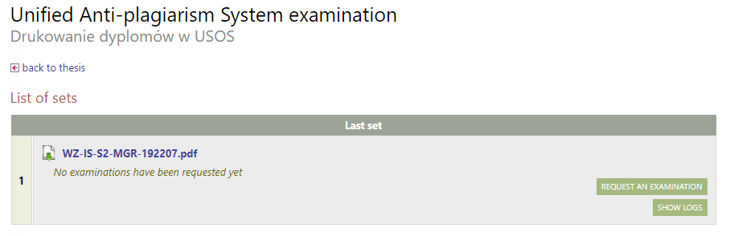

1.5. After the examination by the JSA system, the thesis examination report is available in the APD system. Next, the Supervisor reads the thesis examination report, and, subsequently:
a. If the obtained examination result is not sufficient, the Supervisor clicks on the “Submit for improvement” (“Przekaż do poprawy”) button, and thus sends the thesis back to the Student for improvement/corrections. Then the thesis is sent back to step 2 in the APD system, and the procedure for Remote Defense of Diploma Thesis begins with point 1.3.

b. If the obtained check result is sufficient, the Supervisor accepts the report from the JSA system (see the screen below).
Upon receiving the diploma of completion of studies, the Student shall submit to the Dean’s Office a general report on the JSA examination as Annex 3.1 to the “Declaration of readiness to defend the thesis”.

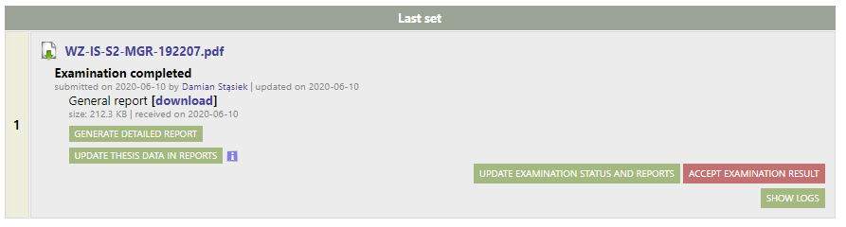

1.6. The Student downloads and fills in the form available in the USOSweb system: “Declaration of readiness to defend the thesis” (“Oświadczenie o gotowości do obrony pracy dyplomowej”, see: Appendix 3).

The Student delivers the printed and signed original documents constituting Appendix 3 to the Dean’s Office at the time of collecting the diploma of the completion of studies.

Submission of applications is available after logging into the USOSweb system in the menu “FOR STUDENTS -> APPLICATIONS -> Submit a new application” (“DLA STUDENTÓW -> PODANIA -> Złóż nowe podanie”).

Please note: before submitting all documents listed in point 1.6 to the USOSweb system, the Student should obtain approvals (“settle accounts”) in the Circulation Document with all departments at the University, i.e. the Main Library, the Department of Students and PhD Candidates’ Accounts, and the student accommodation service.

1.7. The Supervisor proposes a Reviewer by contacting an employee of the Dean’s Office by either phone or e-mail.

1.8. The staff member who has been appointed as the Reviewer is visible to the Student in the APD system.

1.9. After the review is approved by the Supervisor and the Reviewer, the system proceeds to step 5 “Thesis ready for defense” (“Praca gotowa do obrony”).
1.10. The student downloads the “Thesis chart” (“Karta pracy”, see: Appendix 6) and the “Declaration of granting access to the thesis” (“Oświadczenie o udostępnianiu pracy”, see: Appendix 7) from the APD system. The Student delivers the printed and signed originals of these documents to the Dean’s Office when collecting the diploma of the completion of studies.

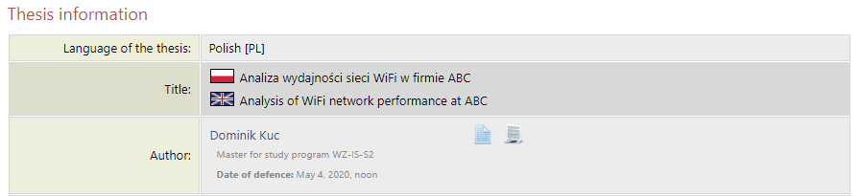
“Emergency Procedure”

Procedure in cases where the diploma thesis has been sent to the ASAP system
and examined by JSA before the remote defense procedure came into force

There are two possible situations:
- The Supervisor has not yet accepted the JSA examination. In that case:
The Supervisor informs the Student that in connection with the entry into force of the remote defense procedure, the Student is to perform all activities as in the said procedure, starting, inter alia, from uploading the thesis into the APD system.

- The Supervisor has already accepted the JSA examination. In that case:
  - The Student uploads the general report from JSA examination to the APD system as an attachment to his/her thesis.
  - If the Supervisor accepts the thesis despite it exceeding the recommended similarity indices (40%), he/she shall complete the form “Justification of diploma thesis originality” (Appendix 2.1), sign it, scan it, and send it to the Student. The Student then uploads Appendix 2.1 into the APD system.
  - Upon receiving information from the Dean’s Office employee about the approval of the Student’s statement and appointing a Reviewer (point 1.12 of the procedure), the Thesis Supervisor sends an e-mail to the address apd-pomoc@uek.krakow.pl containing thesis status information: namely, that the thesis has been previously examined by the JSA system, and that the report has already been accepted.

In its content, the message should include: Student’s first and last name, and Student album number.

  - Further steps are followed according to the procedure.

2. Remote diploma exam

Conducting a remote diploma exam is only possible via the Zoom videoconferencing platform, and using the official e-mail accounts of Staff members in the uek.krakow.pl domain and Student e-mail account(s) in the student.uek.krakow.pl domain.

2.1. The necessary conditions for conducting the remote diploma exam are as follows:
- the Student meets all the requirements set out in chapter 6 of the Study Regulations of the Cracow University of Economics;

- the Student and the Members of the Diploma Examination Board (Chairperson of the Examination Board, the Supervisor, and the Reviewer) each have access to a computer equipped with a microphone and a camera, and a stable Internet connection;
Please note:
- The Members of the Examination Board and the Student should check the technical condition of the computer regarding the camera and the microphone before the exam;
- The student may use a mobile phone during the diploma examination only with the consent of the Chairperson of the Examination Board;

- When taking the exam, the Student should log in using his/her own first and last name. On the Zoom platform it is possible to change the username. In order to do this, click on the “More” button next to the username used so far, then select “Rename” and enter your name and surname.

- The Student is required to take a remote diploma exam in appropriate attire, in accordance with academic custom normally applied during the thesis defense.

2.2. In the absence of appropriate equipment, the Student sends to the Dean’s Office via the USOS system the “Application for participation in a remote diploma examination from within the University campus” (“Podanie o uczestnictwo w zdalnym egzaminie dyplomowym z terenu Uczelni”, see: Appendix 8) in the room indicated by the Dean’s Office employee. The Study Systems Service section and the IT Support section are responsible for making available a room with appropriate equipment, and the Maintenance Department is responsible for epidemiological safety during the diploma examination itself.

2.3. At least 7 days before the scheduled date of the remote diploma examination, an employee of the Dean’s Office, having made prior arrangements, sends information to the Student’s and to Members of the Diploma Examination Board e-mail accounts that the examination date has been set and is available in the APD system.

2.4. Then the Person responsible for setting up a meeting on the Zoom platform (either Chairperson of the Examination Board or Dean’s Office employee or another staff member authorized by the Institute’s Director) immediately sets up the meeting and sends the invitation to the Members of the Examination Board and to the Student or student group.

2.5. On the day of the exam (on the specified date and hour), the Person responsible who has set up a meeting on the Zoom platform launches an online session, for which the Student or the group of Students and all Members of the Diploma Examination Board report five minutes before the scheduled time of its commencement. When starting a session with more than one student, the Chairperson of the Examination Board employs the “waiting room” function.

2.6. During the exam, cameras and microphones of all persons participating in the exam (the Student and the Members of the Diploma Examination Board) must be turned on. The Student presents his/her student ID for verification purposes. While taking his/her diploma examination, the Student should sit in front of the camera and be clearly visible to the Committee throughout the examination. The Student should make sure that there is a calm and quiet room available throughout the online transmission. During the exam, the Student provides access to his/her computer’s desktop, which is the only screen available to the student for the duration of the exam.

For this purpose, the Student clicks on the “Share Screen” button.

2.7. The diploma examination starts with the random draw of the first question, or posing of the first question by the thesis Supervisor. The Supervisor places his/her question in the chat dialogue box by clicking on the “Chat” icon. This is followed by the Student’s answer to the question that had been asked, and the discussion led by the Supervisor. This procedure is then repeated with the second and third questions, respectively. All Members of the Diploma Examination Board (the Chairperson, the Supervisor, the Reviewer) are then able to pose any additional questions. If the Student’s answers require a written or graphic format or presentation of photos and drawings, he/she may edit them in a suitable software application (a word processor, a spreadsheet, a graphics program, etc.) and present them on his/her desktop via the shared screen.
Please note: in the case of diploma exams in the field of Spatial Management, when presenting his/her diploma thesis, the Student provides – via the shared screen on the desktop – either a synthetic board presenting the idea of the thesis, or selected drawings that are part of the diploma project and explaining the concept and/or certain elements of the thesis. It is expedient to prepare all the drawings that are elements of the diploma thesis project for the presentation on the desktop.

2.8. In the event of the transmission of the remote diploma examination being interrupted, the Person responsible for setting up the meeting will attempt to re-establish the connection. If the connection can be established again, the Student either randomly draws or is given a new question. In the event of a further interruption of the remote diploma examination transmission or other unforeseen circumstances, an additional examination date shall be set not earlier than 7 days hence. In this case, the Student shall be taking his/her diploma examination within the University campus, and the Chairperson of the Examination Board shall record this fact in the examination report sheet.

2.9. After the diploma examination is completed, the session with the Student terminates. The Student is directed to the “waiting room” by the Chairperson of the Examination Board.

2.10. After re-inviting the Student or the group of Students to a session with the Diploma Examination Board, the Chairperson of the Examination Board shall announce the diploma examination result that had been determined by the Board. In the event of a positive result of the diploma examination, the Chairperson of the Examination Board shall also provide the final grade of studies and announce the decision to grant the appropriate professional title.

2.11. Within 1 month from the date of the diploma examination, the Student shall submit to the Dean’s Office the originals of the signed documents listed in point 1.6 along with his/her student ID. Then he/she shall receive the diploma of the completion of studies.

List of Appendixes:

Appendix 2.1. Justification of diploma thesis’ originality (Uzasadnienie samodzielności pracy dyplomowej) – filled in by the Thesis Supervisor only in the case of the “Emergency Procedure”.
Appendix 3. Declaration on readiness to defend the thesis (Oświadczenie o gotowości do obrony pracy dyplomowej) – to be completed by the Student
Appendix 6. Thesis chart (Karta pracy) – to be completed by the Student
Appendix 7. Declaration of granting access to the thesis (Oświadczenie o udostępnianiu pracy) – to be completed by the Student

Appendix 8. Application for participation in a remote diploma examination from within the University campus (Podanie o przeprowadzenie zdalnego egzaminu dyplomowego z terenu Uczelni) – to be completed by the Student

Appendix 3. Declaration on readiness to defend the thesis
Appendix No. 3 to the procedure for the remote defense of the diploma thesis

…………………………….......... Kraków, ….…………… (date)
(Student’s name and surname)

……………………
(No. of Student album)

……………………
(Field of study/study major)

……………………
(Form and mode of studies)

………………………
(Telephone number)

Director of the Institute ……………….

…………………………………….

Declaration

I hereby declare that all stages of the educational program have been completed, and that the diploma thesis titled ………………………………………………………………………………… …………………………………...………………………….……………………………………………………………………………...………………………….…………………………………………
was received on ……...…...…… (date) by ……………………………….….…………………
(title, name and surname of thesis Supervisor)

I kindly ask for admission to the remote diploma examination, and for the appointment of a Reviewer.

I acknowledge that, based on the applicable regulations, my diploma thesis will be verified for plagiarism in the Uniform Anti-Plagiarism System, and subject to the positive result of the diploma exam it will be added to the National Repository of Written Diploma Theses in the Integrated Information System on Higher Education and Science (POL-on) maintained by the Minister of Science and Higher Education, with the proviso that the repository does not store the works that may contain any information falling under the provisions on the protection of classified information.

………………………..
(signature of the Student)

Attachments:
2.1. Justification of diploma thesis’ originality (Uzasadnienie samodzielności pracy dyplomowej) – filled in by the Thesis Supervisor only in the case of the “Emergency Procedure”
3.1. General report on the thesis’ examination by the Uniform Anti-Plagiarism System (JSA)
3.1. Additional information for the supplement to the diploma
3.2. Declaration on the processing of the student’s personal data
3.3. Information for the graduates on personal data processing
3.4. Application for issuing the official copy of the diploma/supplement in English

Response to the Declaration on readiness to defend the thesis:
I hereby confirm that all stages of education have been completed, and the conditions for admission to the diploma examination have been met.
I designate the Reviewer of the diploma thesis:
…………………………………………………………….………………………………………

………..…………………
(signature of the Director of Institute)

Appendix 2.1. Justification of diploma thesis’ originality– filled in by the Thesis Supervisor only in the case of the “Emergency Procedure”

Form for the justification of diploma thesis’ originality in the JSA system
Name and surname of the author of diploma thesis:
Student album number of the author of diploma thesis:
Name and surname of the diploma thesis Supervisor:
Does the value of the similarity index 1 – database of legal acts – for the diploma thesis exceed 40%? |  |  | [ ] Yes |  | [ ] No
The value of the similarity index 1
(from the JSA similarity report):
Does the value of the similarity index 2 – Internet database – for the diploma thesis exceed 40%? |  |  | [ ] Yes |  | [ ] No
The value of the similarity index 2
(from the JSA similarity report):
Does the value of the similarity index 3 – the ORPPD database – for the diploma thesis exceed 40%? |  |  | [ ] Yes [ ] No
The value of the similarity index 3
(from the JSA similarity report):
Does the value of the similarity index 4 – the institutional database – for the diploma thesis exceed 40%? |  |  | [ ] Yes [ ] No
The value of the similarity index 4
(from the JSA similarity report):
Justification of diploma thesis’ originality
(Why, despite the similarity index (indices) 1, 2, 3 and/or 4 exceeding the threshold in the JSA similarity report, can the diploma thesis be considered to be original/independently written?)
(place) | (date) |  |  | (Thesis Supervisor’s signature)

Appendix 3.2. to the Declaration on readiness to defend the thesis
Additional information for the supplement to the diploma
Name and surname:
Institute:
Study major:
Special field:
No. of Student album:

Student placements/experience during the course of studies (name of organisation, placement duration):

..............................................................................................................................................................

..............................................................................................................................................................

Participation in Student Scientific Clubs (*):

............................................................................................................................................................

............................................................................................................................................................

Awards granted (*):

...........................................................................................................................................................

...........................................................................................................................................................

Scholarships granted for outstanding learning outcomes (*) and accomplishments in the sports (*):

............................................................................................................................................................

............................................................................................................................................................

Study placements abroad, e.g. with ERASMUS (name of the program, name of the host University, in which semester the placement abroad took place):

………………………………………………………………………………………………………………………………………………………

Participation in the ACCA Route¹ (*): □ YES □ NO

Kraków, date ................... Signature: ...............................................

* If activities are quoted in the statement, it is essential to attach relevant documents
(e.g. certificates, photocopies of the records) confirming the indicated information
1 – check the appropriate option

Appendix 3.3. to the Declaration on readiness to defend the thesis

Declaration on the processing of the student’s personal data

Appendix to the Rector’s Regulation

No. R-0201-54/2018 of 9 November 2018

Name and surname *

Address for correspondence *

E-mail address *

Telephone number

Faculty/department

Study major
* - mandatory data

Pursuant to Article 6 (1) (a) of Regulation (EU) 2016/679 of the European Parliament and of the Council on the protection of individuals with regard to the processing of personal data and on the free movement of such data and repealing Directive 95/46/EC (General Regulation on data protection – hereinafter GDPR) of 27 April 2016 (Journal of Laws EU L 2016, No. 119):
YES NO
I consent to the processing of my personal data regarding my telephone number, faculty/department and study major by the Cracow University of Economics with the view to monitoring the careers of CUE graduates, thus enabling the CUE to adapt its study program and curricula to the needs of the labour market.
YES NO
I consent to the processing of my personal data, specifically my e-mail address and telephone number, for the purpose of Cracow University of Economics sending me information about events (conferences, sessions, symposia, congresses, job fairs, etc.) organised by the CUE.

…………………………………………………..
(date and signature of the graduate)

Appendix 3.4. to the Declaration on readiness to defend the thesis
Information for the graduates on personal data processing

Pursuant to Article 6 (1) (a) of Regulation (EU) 2016/679 of the European Parliament and of the Council on the protection of individuals with regard to the processing of personal data and on the free movement of such data and repealing Directive 95/46/EC (General Regulation on data protection – hereinafter GDPR) of 27 April 2016 (Journal of Laws EU L 2016, No. 119), we would like to inform you that:

- The administrator of your personal data is the Cracow University of Economics (CUE) with headquarters in Kraków, at Rakowicka 27, 31-510 Kraków (hereinafter: the “Administrator”);

- Contact details to the Data Protection Officer are: iod@uek.krakow.pl.

- Based on and to the extent indicated in art. 352 paragraph 15 of the Act of 20 July 2018 Law on Higher Education and Science (Journal of Laws 2018.1668), Your personal data i.e. name and surname, address for correspondence and e-mail address will be processed with the view to monitoring the professional careers of CUE graduates, thus enabling the CUE to adapt its study programs and curricula to the needs of the labour market. Pursuant to and subject to your consent, other personal data provided in the statement regarding the processing of the graduate’s personal data shall be processed for the same purpose, including your contact telephone number, faculty and field of study (study major).

- Pursuant to and subject to your consent, your personal data will also be processed for the purpose of CUE sending you information about events (conferences, sessions, symposia, congresses, job fairs, etc.) organized by the Cracow University of Economics. The basis for processing is your consent (article 6, section 1, point a) of the GDPR).

- Your personal data may be shared with relevant recipients, in particular, external entities dealing with IT support or legal support for the administrator or with institutions authorized to control the administrator’s activities, and entities authorized to access data pursuant to relevant provisions of law.

- Your personal data will be processed for a period of no more than 10 years from the date of your graduation or until your consent is withdrawn.

- Your consent to the processing of personal data is always voluntary.

- You have the right to request from the Administrator the access to your personal data, in order to rectify it, to delete it, or to limit its processing, as well as the right to object to the processing, and the right to transfer the data – in cases and on the terms specified in the provisions of the GDPR;

- To the extent that the basis for the processing of your personal data is consent, you have the right to withdraw it at any time. Withdrawal of consent does not affect the lawfulness of processing based on consent before its withdrawal.

- You have the right to lodge a complaint with the supervisory body – the President of the Personal Data Protection Office, should you conclude that the processing of your personal data infringes upon the provisions of the GDPR.

- Your personal data will not be subject to the process of automated decision making or profiling.

- The administrator will not transfer your data to recipients in third countries.

I confirm to have read and agree to the information above: ….........................................................

(date and signature of the graduate)

Appendix 3.5. to the Declaration on readiness to defend the thesis

Application for issuing the official copy of the diploma/supplement in English

Kraków, …………………………. (date)
……………………………………………………………
Name and surname
…………………
No. of Student album:
……………………………………………………………
Field of study/study major, form and mode of studies, semester
…………………………………………………………………………………………….
Address for correspondence

To the Director of the Institute ……………..
………………………………………………….

I hereby kindly ask for the issue of a certified copy of the diploma of completion of MSc/BSc studies and the supplement in the English language.
I have taken the diploma exam on ………………………………….… (date) in the …………………………………………………. study major.

Appendix 6. Thesis chart
DIPLOMA THESIS CHART
Given name(s):
Family name:
PESEL (personal identification number):
No. of Student album:
Form/mode of studies: full-time program
Unit granting the title: Institute
Code of the diploma:
Description of the diploma:
Thesis supervisor:
Title of the thesis:
Title of the thesis in English:
Keywords:
Abstract:

Field of the diploma thesis: …
Whether the thesis is of confidential nature (it will not be sent to the ORPD): …
Date of thesis submission:
Date of the examination:

(author’s signature)

Appendix 7. Declaration of granting access to the thesis

DECLARATION
Name and surname
Institute
Cracow University of Economics

I hereby declare that:
- The digital version of the diploma thesis [……. title of the thesis ……] is the final version submitted for defense at the Cracow University of Economics.
- The diploma thesis that I have submitted is my own and original work.
- I grant to the Cracow University of Economics a royalty-free non-exclusive license to place my diploma thesis in the digital system of the Diploma Theses Archive, and to reproduce and disseminate the work to the extent necessary in order to protect my copyrights or the rights of third parties.
- I consent to / I do not consent to making my thesis available at the reading room of the Cracow University of Economics library.
- I consent to / I do not consent to making my thesis available online via the Internet.

(author’s signature)

Appendix 8. Application for participation in a remote diploma examination
from within the University campus
Application
Due to the fact that I do not have the appropriate computer equipment and/or stable Internet connection available, I would like to apply for the option to take the diploma exam from within the University campus, in a specially adapted room.
……………………… ……………………………
Name and surname Place, date
………………………
Field of study/study major
………………………..
No. of Student album
……………………….
Form and mode of studies
………………………..
Phone number
………………………..
Student’s signature
………………………..

Delete as appropriate

